Scaling Risk Estimates – VaR(95%) Forecast
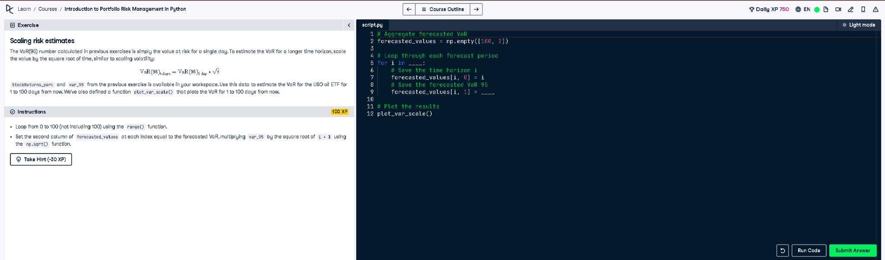

Python Code
# Aggregate forecasted VaR
forecasted_values = np.empty([100, 2])
# Loop through each forecast period
for i in range(100):
# Save the time horizon i
forecasted_values[i, 0] = i
# Save the forecasted VaR 95
forecasted_values[i, 1] = var_95 * np.sqrt(i + 1)
# Plot the results
plot_var_scale()

Simple Explanation (50 Words)
This code forecasts VaR(95%) from 1 to 100 days by scaling the one-day VaR using the square root of time. It uses a loop and multiplies the single-day VaR by sqrt(i+1) to get the value at each horizon. Results are stored and plotted using plot_var_scale().

